“Query Processing – Implementation of DBMS” (WS 24/25, Prof. Dr. Justus Klingemann).

🔑 Topics in the Lecture Note

1. Query Processing and Query Plans
- A query plan defines how a database executes a SQL query.
- Steps:
  - Choose operations: Selection (σ), projection (π), join, etc.
  - Order operations: What comes first? Join before selection or vice versa?
  - Execution strategy:
    - Join method (nested loop, hash join, merge join).
    - Pipelining: feed output of one operator directly to another (avoids storing large intermediate results).
    - Use indexes or not.
    - Decide if intermediate results should be sorted.
👉 Key Point: There can be many equivalent plans for one SQL query, but some are much faster.

2. Example Query
SELECT B, D
FROM R, S
WHERE R.A = 'c' AND S.E = 2 AND R.C = S.C;
- Tables R(A, B, C) and S(C, D, E) are joined.
- Conditions:
  - R.A must equal "c".
  - S.E must equal 2.
  - R.C must equal S.C (join condition).
- Output: attributes B, D.
👉 Different query plans can produce the same result but with different costs.

3. Plans for Query Execution
Plan I:
- Do full Cartesian product R × S.
- Apply selection conditions.
- Project B and D.
  - Very expensive, because R × S may be huge.
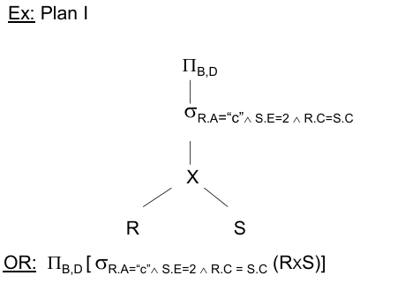
Plan II:
- Apply selections first (σR.A="c", σS.E=2).
- Do a natural join.
- Project.
  - Much faster than Plan I, because we filter before joining.
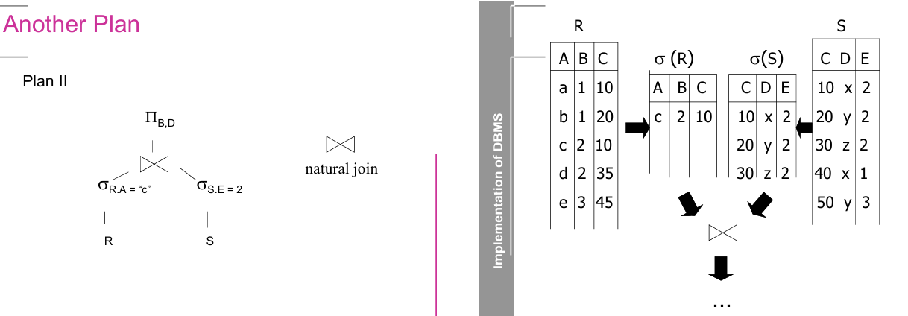
Plan III:
- Use indexes:
  - Use index on R.A to directly find tuples with R.A="c".
  - Use index on S.C to quickly find matches for R.C.
  - Filter S by S.E=2.
  - Most efficient plan, avoids scanning entire relations.
👉 Lesson: Plans differ in cost depending on indexes and join order.
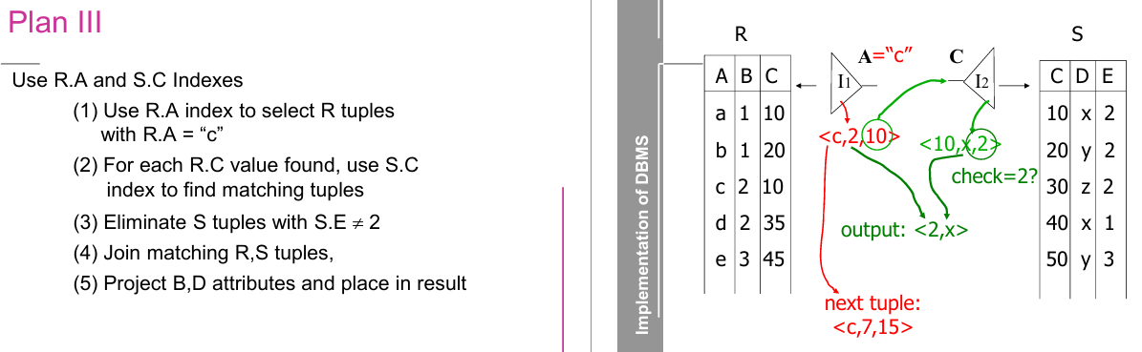

4. Query Optimization Workflow
Steps to optimize:
- Parse SQL query → build parse tree.
- Convert to relational algebra expression (logical query plan).
- Apply algebraic laws to improve plan (push selections/projections down).
- Estimate sizes of intermediate results (using statistics).
- Generate physical plans (different join methods, indexes).
- Estimate costs of each plan.
- Pick best plan and execute.

5. Example: SQL with Subquery
SELECT title
FROM StarsIn
WHERE starName IN (
SELECT name
FROM MovieStar
WHERE birthdate LIKE '%1960'
);
- Parse Tree: represents nested structure of SQL.
- Logical Plan: relational algebra with selections and joins.
- Improvement: push down projections (πtitle, πname) early to reduce tuple sizes.
- Estimate result sizes to choose efficient join order.

6. Physical Query Plans
- Choice depends on:
  - Join order (R ⋈ S vs. S ⋈ R).
  - Join algorithm (nested loop, hash join, sort-merge).
  - Index scan vs. sequential scan.
  - Available memory.
👉 Optimizer chooses based on cost estimates (I/O + CPU).

7. Algebraic Transformations
Used to generate equivalent query plans:
- Cross product and join rules:
  - R × S = S × R (commutative).
  - (R × S) × T = R × (S × T) (associative).
  - Joins are also associative and commutative.
- Selection rules:
  - σp∧q(R) = σp(σq(R)) (can split conditions).
  - σp∨q(R) = (σp(R)) ∪ (σq(R)).
- Projection rules:
  - πXY(R) = πX(πY(R)) (can push projections down).
- Combination rules:
  - Selections and projections can often be pushed down closer to base tables → smaller intermediate results.
👉 Main Idea: Rearrange algebra operations to reduce cost while keeping the result the same.

📌 Why This Matters
- Query processing is the heart of a DBMS.
- The difference between a naive plan and an optimized one can be seconds vs. hours.
- DB optimizers rely heavily on:
  - Algebraic rules (theory).
  - Statistics (practical data distribution).
  - Cost models (to decide the fastest way).

✅ Now you understand:
- What a query plan is.
- How the optimizer transforms SQL into relational algebra.
- How different plans affect performance.
- The role of indexes, join order, and algebraic transformations.

📌 Query Processing Cheat Sheet (DBMS WS 24/25)

🔹 1. Query Plans
- Query plan = strategy to execute SQL query.
- Choices:
  - Operations (σ, π, ⋈, ×).
  - Order of operations.
  - Join method (nested loop / hash join / sort-merge).
  - Use of indexes or not.
  - Pipelining vs. materialization.

🔹 2. Example Query
SELECT B, D
FROM R, S
WHERE R.A='c' AND S.E=2 AND R.C=S.C;
- Plan I: (R × S) → σ → π (expensive).
- Plan II: σ first → ⋈ → π (better).
- Plan III: Use indexes on R.A & S.C → σ → ⋈ → π (best).

🔹 3. Query Optimization Workflow
- Parse SQL → Parse tree.
- Convert → Relational algebra (logical plan).
- Apply algebraic laws → Improved plan.
- Estimate sizes (using stats).
- Generate physical plans.
- Estimate costs.
- Pick cheapest plan → Execute.

🔹 4. Algebraic Transformations

Joins / Cross Product / Union
- Commutative: R × S = S × R ; R ⋈ S = S ⋈ R
- Associative: (R × S) × T = R × (S × T) ; (R ⋈ S) ⋈ T = R ⋈ (S ⋈ T)

Selection (σ)
- σp∧q(R) = σp(σq(R))
- σp∨q(R) = σp(R) ∪ σq(R)

Projection (π)
- πXY(R) = πX(πY(R))
- Push π down early to shrink tuples.

Combined
- σp(R ⋈ S) = (σp(R)) ⋈ S (if p only on R)
- πx[σp(R)] = σp[πxz(R)] (if z ⊆ attrs in p)

🔹 5. Physical Plan Choices
- Access method: Sequential scan vs. Index scan.
- Join methods:
  - Nested loop (simple, slow).
  - Sort-Merge (requires sorting).
  - Hash join (fast, if memory fits).
- Parameters: join order, memory size, available indexes, projected attributes.

🔹 6. Key Optimization Principles
- Push σ (selection) and π (projection) down as far as possible.
- Use indexes when possible.
- Reduce intermediate result sizes early.
- Choose best join order (biggest impact on performance).
- Estimate costs (I/O + CPU).

✅ Exam Tip: Always think:
- Can I filter earlier?
- Can I use indexes?
- What’s the join order?

